Chapter 1 (Size 11)

Deep Science Publishing

<https://doi.org/10.xxxx/xxxxx.xxxxx>

Machine learning and deep learning architectures and trends (Size 22)

First Author 1, Second Author 2, Third Author 3 (Size 11)

*1 Department, University, State, Country. (Size 10 &italic)*

*2 Department, University, State, Country. (Size 10 &italic)*

*3 Department, University, State, Country. (Size 10 &italic)*

[*1 correspondingauthor@IEEE.org(Size9)*](mailto:1%20correspondingauthor@IEEE.org(Size9))

**Abstract:** (Size 10) Use Times New Roman font throughout the manuscript for consistency and readability. The advancement of Machine Learning (ML) together with Deep Learning (DL) has been revolutionizing many fields through advances in data-driven decision-making, automation, and predictive analytics. This has formed the keystone for the exploration of the most recent architectures and upcoming trends in said domains as to how they are significantly impacting other sectors.

**Keywords:** (Size 10) 5-6 keywords arranged alphabetically and separated by commas.

|  |
| --- |
| **Citation:** Surname, N. L., Surname, S. K., Surname, O., & Surname, J. (2024). Chapter title. In *Book Name* (pp. 25-58). Deep Science Publishing. <https://doi.org/10.70593/978-> |

**1.1 Introduction (Size 11 & bold)**

The fields of healthcare and finance have seen significant changes as a result of Machine Learning (ML) and Deep Learning (DL), which enable machines to learn from data and make decisions with minimal human intervention. **Use Times New Roman of size 11 and spacing 1.15 for text. Use APA citation style for both in-text citations and the reference list** (Chauhan & Singh, 2018; Shrestha & Mahmood, 2019). These technologies' adoption and expansion have been accelerated by the rapid advancement of processing power and the wealth of available data (Shinde & Shah 2018; Shrestha & Mahmood, 2019; Dargan et al., 2020). The ML and DL architectures, which are the foundation of these technologies, have made significant progress and shown remarkable capabilities in tasks such as natural language processing, autonomous systems, and image and audio recognition. ML models come in a variety of architectures, from basic linear regression models to intricate neural networks, designed for different tasks and types of data (Chauhan & Singh, 2018; Sengupta et al., 2020; Alzubaidi et al., 2021). DL, a branch of ML, utilizes neural networks with multiple layers to capture complex patterns and features in data (Minar & Naher, 2018; Dargan et al., 2020; Alzubaidi et al., 2021). Architectures such as Convolutional Neural Networks (CNNs), Recurrent Neural Networks (RNNs), and Generative Adversarial Network (GANs) have expanded the capabilities of machines, resulting in advancements in computer vision, speech synthesis, and generative art. Fig. 1.1 shows the co-occurrence analysis of the trending keywords in ML. Table 1.1 shows the key architectural innovations and enhancements in ML and DL.

https://deepscienceresearch.com

**1.2 Literature review**

Fig. 1.1 shows the co-occurrence analysis of the trending keywords in ML. Table 1.1 shows the key architectural innovations and enhancements in ML and DL. Ensure that all tables and figures are properly cited within the text.

**1.3 Methods and materials**

Fig. 1.1 shows the co-occurrence analysis of the trending keywords in ML. Table 1.1 shows the key architectural innovations and enhancements in ML and DL.

**1.4 Results and discussions**

Fig. 1.1 shows the co-occurrence analysis of the trending keywords in ML. Table 1.1 shows the key architectural innovations and enhancements in ML and DL.

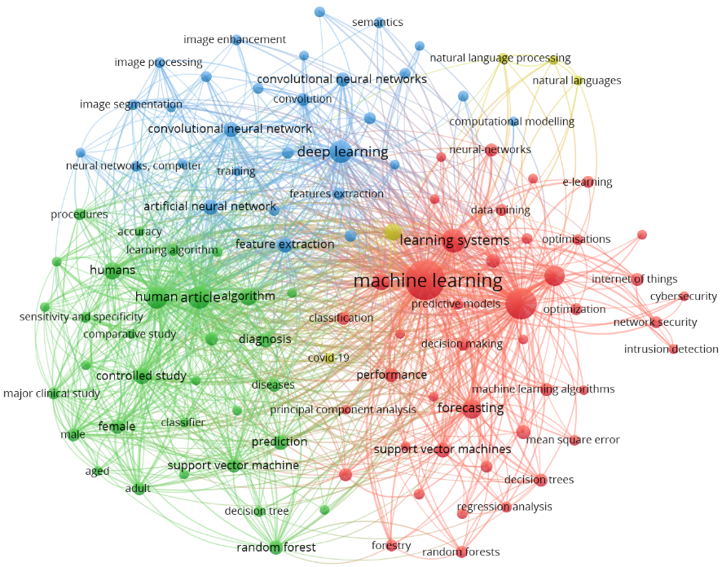

**Fig. 1.1** Co-occurrence analysis of the trending keywords in ML

**Table 1.1** Key architectural innovations and enhancements in ML and DL. Text within tables should be set in size 10.

|  |  |  |  |  |  |
| --- | --- | --- | --- | --- | --- |
| **Sr. No.** | **References** | **Architectural Innovation** | **Description** | **Enhancements** | **Key Applications** |
| 1 | (Shrestha & Mahmood, 2019; Aziz et al., 2020; Deng, 2014) | Convolutional Neural Networks (CNNs) | A category of deep neural networks predominantly employed for scrutinizing visual stimuli. | Noteworthy advancements encompass escalated precision in discerning and categorizing visual data, alongside refined extraction of features facilitated by convolutional strata. | Disciplines of interest encompass image and video analysis, in addition to the burgeoning field of medical imaging. |
| 2 | (Alzubaidi et al., 2021; Janiesch et al., 2021; Wu & Xie, 2022) | Recurrent Neural Networks (RNNs) | Neural network architectures characterized by sequential interconnections, adept at processing time-series data. | Distinctive enhancements embrace proficient handling of sequential datasets. | Application domains span language modeling, speech recognition, and the domain of time-series prediction. |

**Conclusions**

Transformer-based models such as BERT have caused a significant change in the field of NLP and consistently establish higher levels of performance. These models use self-attention mechanisms to better capture contextual information compared to traditional RNNs and CNNs.

**References**

Alom, M. Z., Taha, T. M., Yakopcic, C., Westberg, S., Sidike, P., Nasrin, M. S., ... & Asari, V. K. (2019). A state-of-the-art survey on deep learning theory and architectures. electronics, 8(3), 292. (Size-10) Use APA style for both in-text citations and the reference list

Alzoubi, Y.I., Mishra, A. & Topcu, A.E. (2024). Research trends in deep learning and machine learning for cloud computing security. Artif Intell Rev 57, 132.

Alzubaidi, L., Zhang, J., Humaidi, A. J., Al-Dujaili, A., Duan, Y., Al-Shamma, O., ... & Farhan, L. (2021). Review of deep learning: concepts, CNN architectures, challenges, applications, future directions. Journal of big Data, 8, 1-74.

Angulakshmi, M., & Deepa, M. (2021). A review on deep learning architecture and methods for MRI brain tumour segmentation. Current Medical Imaging, 17(6), 695-706.

Avci, O., Abdeljaber, O., Kiranyaz, S., Hussein, M., Gabbouj, M., & Inman, D. J. (2021). A review of vibration-based damage detection in civil structures: From traditional methods to Machine Learning and Deep Learning applications. Mechanical systems and signal processing, 147, 107077.

Aziz, L., Salam, M. S. B. H., Sheikh, U. U., & Ayub, S. (2020). Exploring deep learning-based architecture, strategies, applications and current trends in generic object detection: A comprehensive review. Ieee Access, 8, 170461-170495.